Make a Buck: Unique Adding Decimals Game

**How to Play Make a Buck**:

***The object of this game*** *is to be the first person to collect****ten cards****that****exactly equal $1.00****.*

This game is played using [a complete deck of cards](http://amzn.to/2mHDGuJ).   In this game, Ace = $0.01, Two = $0.02, Three = $0.03, … Tens = $0.10, Jack = $0.11, Queen = $0.12 and King = $0.13.

To begin, shuffle the deck and **deal ten cards to each player**.

Players then take turns **drawing and discarding one card at a time** until the deck of cards is depleted or a player collects exactly $1.00.

This means it will involve a bit of **logic and problem solving** as kids learn to discern which cards to keep and which to discard, as well as thinking through **possible ways to collect $1.00**.

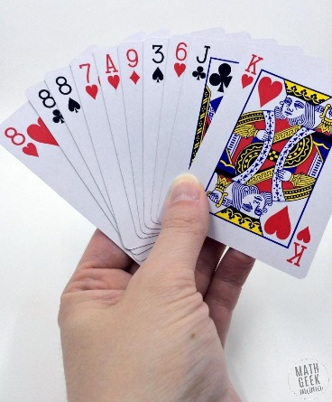

For example, in the hand shown above, **the total would be $0.74**. So, you would want to start by discarding the smaller card values to try and get larger ones, and then go from there.

**Scoring:**

* The first player to collect ten cards that equal $1.00 **wins that round** and **earns 1 point**.
* If no one has $1.00 after [the deck is depleted](http://amzn.to/2mHDGuJ), the person closest (without going over) **earns .5 of a point**.
* **The player with the most points at the end of ten rounds wins!**

**Variations to Make a Buck Card Game:**

For younger kids, you could change the cards to **whole number values** and play to $100. For instance, Ace = $1, Two = $2 and so on.

Or to work on **integer operations**, make the black cards **positive values** and red cards **negative values** and play to zero.